[Project] Personal Goals Report
Prepared By [your Name]
[date]

Notes (delete these before submitting)
- include at least 2-3 technical risks associated with what you are working on
- use paragraphs or expand to detailed bullets to be informative and appropriate
- include short description of consequence along with a brief description of mitigation strategy in the risk table
- Provide some brief background and detail on plans. "Testing will be performed" is not detailed enough: why, how, and what is being tested to verify what requirements?
- Tell me which deliverable documents you are responsible for
- Figures and tables should be referenced and described in the text
- SAVE your final report as a PDF and submit to your project advisor.

Summary of End of Semester Goals and Deliverables
[Description of three items: i) major technical milestones to achieve for your subsystem this semester; ii) your personal goals: what you want to learn and skills you want to develop; and iii) what documents you are responsible for or working on this semester.]

Approach
[describe the tools you are using, design methodology, how will you complete your tasks]

Schedule
[updated waterfall chart image (see below) using Excel, Google Sheets, or whatever you prefer; justify with a short description of the tasks and the schedule.]

Table 1: [caption]
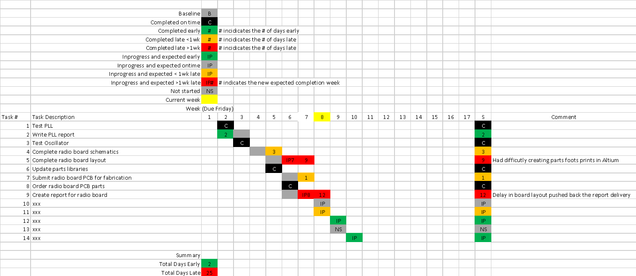

Risks
[risk table. Enter values and comments in the table; expand on description in a paragraph as necessary.]
Table 2: [caption]
[Note: C/L = Consequence and Likelihood. See NASA risk matrix (on Canvas, in Reading folder) for what 1-5 means for each.]

Rank  C/L | Risk Element and Description | Mitigation Strategy / Consequence
No 1:  5,2 | Solar panels deployment | Robust testing on the ground in realistic environment. A run-in test shall be performed for at least 15 cycles. Impact…
No 2:  1,3 | Magnetic distortion of plasma inflow into CIP due magnetic fields from bus. | SIMION modeling of ion trajectories as well as a system level test of the ion-optics (6U CubeSat in calibration chamber at LASP) to characterize the effect and obtain calibration curves to remove it from the data. (Impact objective O3)
No 3:
5,2
No 5;
5,1
No. 6;
4,2

[stoplight chart: show values of C/L for each risk, pre- and post-mitigation.]
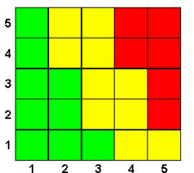

Likelihood
Consequence
2
1,3
4
5
6
Figure 1: [caption]

